**School of Computer Science**

**UNIVERSITY OF PETROLEUM AND ENERGY STUDIES**

**DEHRADUN, UTTARAKHAND**



**OPERATING SYSTEM LAB**

**Lab File**

**(2023-2024)**

**for**

**3rd Semester**

**Submitted To : Submitted By :**

Alok Jhaldiyal Akshat Negi

Assistant Professor-SS Btech CSF

School of Computer Science 500106533

Batch 2

**Experiment No 1: System calls & I/O System calls**

i) To write programs to perform following operations in UNIX:

a) Process Creation

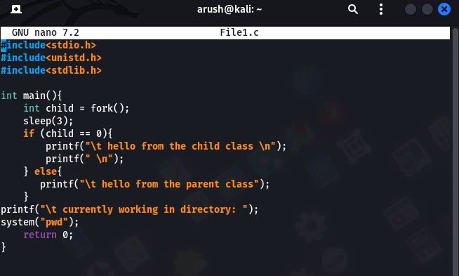

b) Executing a command



c) Sleep command



d) Sleep command using get pid

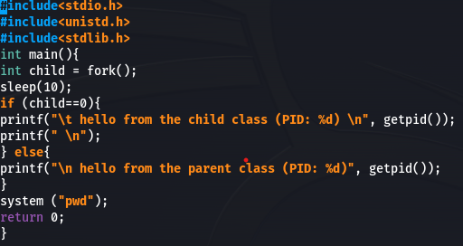

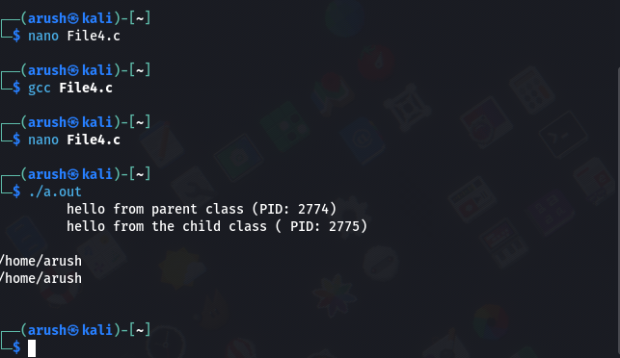

e) Signal handling using kill

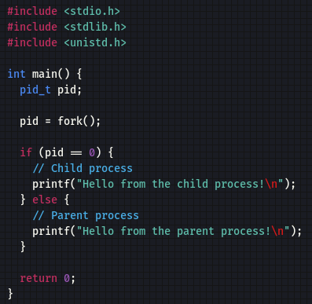

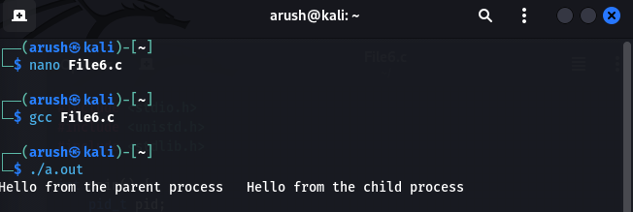

f) Wait command

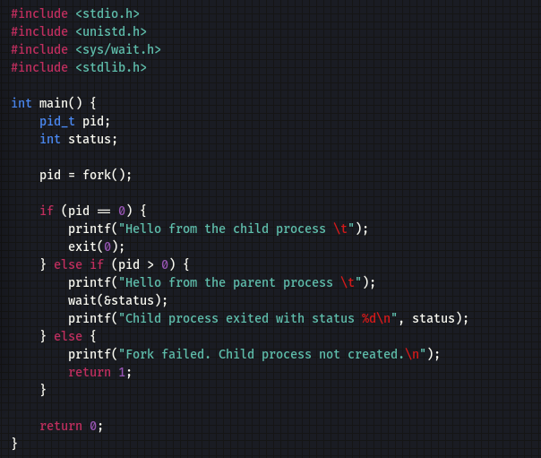

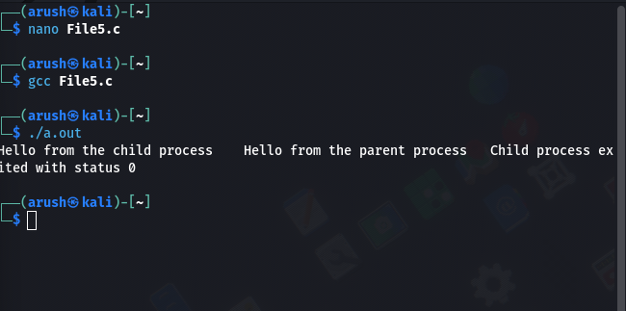

ii) To write programs to perform following operations in UNIX:

1. Reading from a file

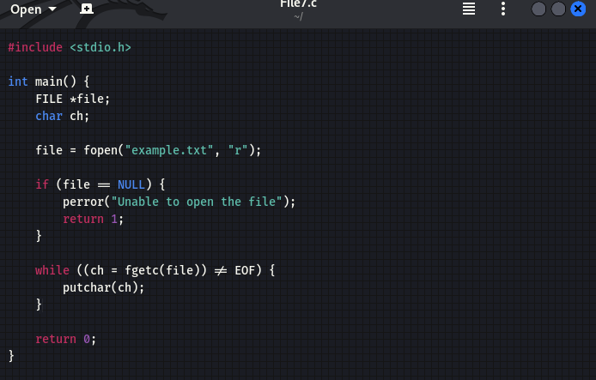

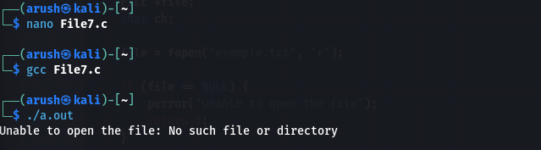

b)Writing into a file

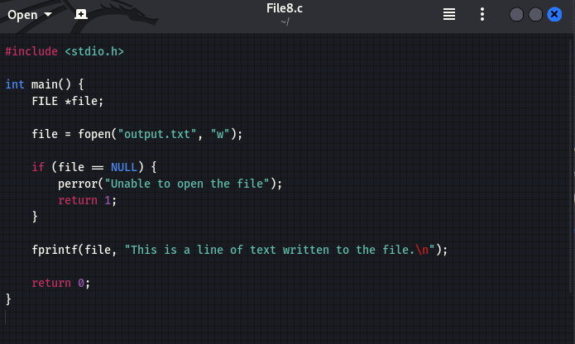

c)File Creation

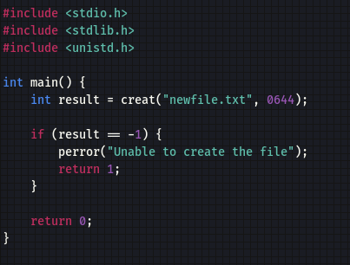

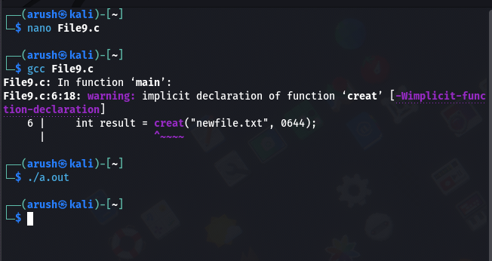

d) Implementation of ls command

